# **Clinical Trial Data Analysis: Diabetes Prediction**

## Project by: Apurva Kumari

## **Objective**

The objective of this project is to analyze clinical trial data to predict whether an individual has diabetes based on key health indicators such as Glucose, Blood Pressure, Skin Thickness, Insulin, and BMI. This prediction is clinically important for early detection and management of diabetes, which is a chronic disease with significant health risks.

### **Goals:**

* Understand the structure and quality of the dataset.
* Identify and handle missing or biologically implausible values.
* Visualize data distributions to reveal trends.
* Prepare data for potential machine learning models.

## **Dataset Overview**

The dataset contains the following features: - Pregnancies - Glucose - Blood Pressure - Skin Thickness - Insulin - BMI - Diabetes Pedigree Function - Age - Outcome (1 = Diabetic, 0 = Non-Diabetic)

## **Data Cleaning & Preprocessing**

* Identified values like 0 for Glucose, Insulin, BMI, etc., which are biologically impossible.
* Treated these as missing values.
* Imputed them using statistical techniques (e.g., mean or median).

## **Exploratory Data Analysis (EDA)**

* Used KDE plots to examine the distribution of clinical variables.
* Visualized both the mean and median to assess skewness.

### Example KDE Insights:

* Glucose: Skewed distribution, with a mean higher than the median.
* BMI: Reveals outliers and central tendency.

These insights help clinicians understand typical vs. abnormal ranges in the population.

## **Why Are We Predicting Diabetes?**

Predicting whether someone has diabetes based on clinical data is crucial for:

### 1. Early Detection

* Many individuals with early-stage diabetes show no symptoms.
* Prediction models can flag at-risk individuals for early intervention.

### 2. Preventive Healthcare

* Enables proactive lifestyle or medical interventions.

### 3. Risk Stratification

* Helps healthcare providers prioritize care.

## **Clinical Significance**

### ✅ Reducing Complications

* Early intervention prevents complications such as heart disease, kidney failure, and neuropathy.

### ✅ Improving Patient Outcomes

* Supports timely treatments, better prognosis, and improved quality of life.

### ✅ Supporting Public Health

* Scalable prediction models can be deployed in mass screenings and remote areas.

## **Clinical Trial Relevance**

Prediction models are directly useful in clinical trials in the following ways:

### 1. Patient Selection

* Filters trial participants based on risk profile.

### 2. Stratification and Randomization

* Ensures equal distribution of diabetic/non-diabetic patients across groups.

### 3. Monitoring

* Predicts treatment response and monitors adverse changes.

### 4. Data Quality

* Identifies and corrects missing or invalid clinical entries.

### 5. Subgroup Analysis

* Evaluates which patient profiles respond best to interventions.

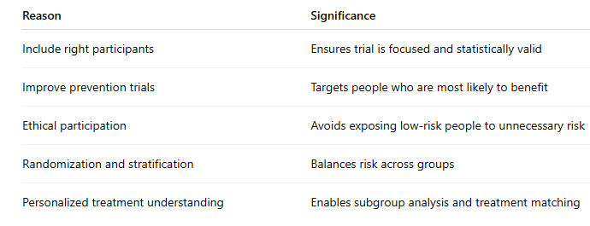

## **Conclusion**

This project demonstrates the value of data analysis in a clinical context: - Identifies and corrects key data issues. - Reveals patterns using KDE and summary statistics. - Provides insights that aid in the design and execution of clinical trials.

Such analysis not only supports data quality improvement but also directly contributes to better patient outcomes and smarter clinical decisions.